**Bedlington Partnership of Schools – Parent code of conduct**

**As well as following the guidance set out in our Home-School Agreement, we ask that you take note of the following:**

* Please treat all staff with dignity and respect.
* Understand that teachers and parents need to work together for the benefit of their children.
* Please approach the school to help resolve any areas of concern.
* Violence towards members of staff will not be tolerated.
* We do not expect staff to be subjected to any form of verbal abuse, threatened or assaulted in any way.
* Abusive or threatening emails or phone messages will not be tolerated.
* Defamatory, offensive or derogatory comments regarding the school or any of the pupils/parents/staff at the school on Facebook or other social sites will not be tolerated (see Appendix 1).

**We also expect parents to conduct themselves in an appropriate manner while on the school site and do not expect that our staff, pupils or other parents are exposed to:**

* Loud offensive language, swearing (including racist and homophobic language) and displays of temper
* Verbal or physical abuse or threats
* Smoking
* Inappropriate behaviour from other children who are in your care

Any of these behaviours could result in the offender being asked to leave the premises or the involvement of the Police.

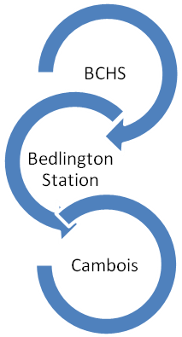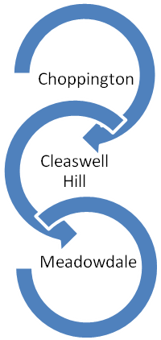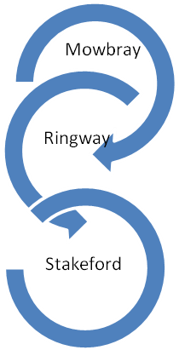

Whitley Memorial

