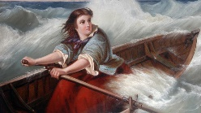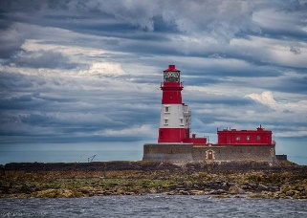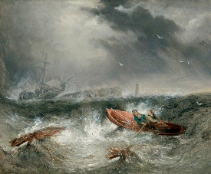**Grace Darling**

Art

* Portraits
* Seascapes

Design Technology

* Textiles: pouches

Music

Friendship Song

Science – Plants

* Observe and describe how seeds and bulbs grow into mature plants.
* Find out and describe how plants need water, light and a suitable temperature to grow and stay healthy.

**Maths**

* Recognise, find, name and write fractions $\frac{1}{3}$, $\frac{1}{4}$, $\frac{2}{4}$ and $\frac{3}{4}$ of a length, shape, set of objects or quantity
* Write simple fractions for example, $\frac{1}{2}$ of 6 = 3 and recognise the equivalence of $\frac{2}{4}$ and $\frac{1}{2}$.
* Choose and use appropriate standard units to estimate and measure length/height in any direction (m/cm).
* compare and order lengths and record the results using >, < and =

Topic – Grace Darling

* Learn about the lives of significant individuals in the past who have contributed to national and international achievements.
* Learn about significant historical events, people and places in their own locality.
* Learn about the life of Grace Darling and her participation in the rescue of survivors from the shipwreck Forfarshire.
* Understand why Grace Darling is famous.
* Compare Grace Darling to modern day heroes.

**English**

This half term we will be reading ‘Fantastically Great Women Who Made History”. We will be:

* Writing descriptions of real people
* Writing a letter
* Writing a newspaper article
* Creating an information text.  
    
  Spellings
* The *ee*sound spelt **ey**
* Adding the suffix -ness
* Words ending in -il

Spanish

Los Helados (ice cream)

RE/PSHE

Islam – Community and Belonging: Does going to the mosque give Muslims a sense of belonging?

PSHE: Relationships

PE

Modified Team Games

Commando Joe unit – The Queen

Computing

Digital Literacy – taking and using photos