Ringway Primary School
Computing Progression Grid
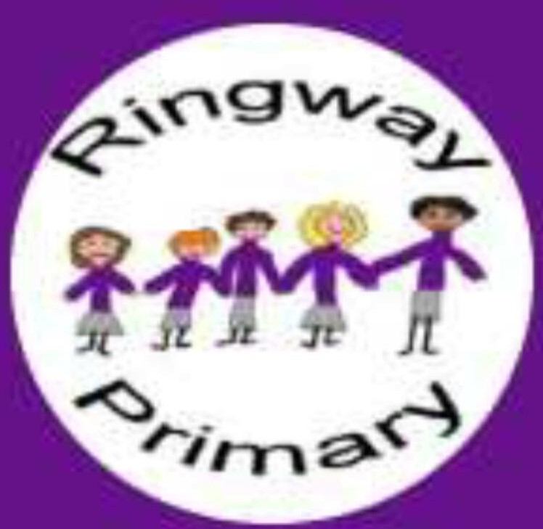
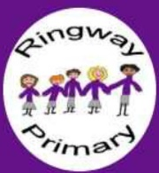

Digital Literacy
 | At Key Stage One:  Knowledge and Skills:  To recognise common uses and purposes of technology  Use technology safely and respectfully.  Keep information privately.  Identify where to go for help/support if they have concerns  Vocabulary:  Technology  Purposes  E-Safety  Cyberbullying  Personal information  Password  private | At Lower Key Stage Two:  Knowledge and Skills:  Understand how the internet offers opportunities for communication and collaboration.  Follow a simple search to find specific information from a website safely.  Find and use appropriate information from a website safely.  Vocabulary:  Website  Results  Address  World Wide Web (www)  Navigate  Web page  Search engine  Trustworthy  Digital  Browser  Secure | At Upper Key Stage Two:  Knowledge and Skills  Understands the opportunities computer networks offer for collaboration  Evaluate digital content  Vocabulary:  Communication  Sources  Validity  Data  Viewpoints  Copyright  Advertising  Publish  Spam  virus
Computer Science
 | At Key Stage One:  Knowledge and Skills:  To understand the purpose of a range of different technology eg tablets, laptops, microphones  To understand what algorithms are and how we use them  Create and debug simple programs (Beebots and Scratch Jr)  Create precise and unambiguous instructions  Use logical reasoning to predict behaviour of simple programmes.  Vocabulary:  Technology  Tablets  Laptops  Microphones  Algorithm  Debug  Date  Program  Precise  Logical reasoning  Evaluate. | At Lower Key Stage Two:  Knowledge and Skills:  Design and create a range of programs, systems and content  Design, write and debug programs that accomplish specific goals (Scratch)  To use logical reasoning to explain how some simple algorithms work.  Create, edit and define more complex sequences of instructions fir a variety of programmable devices  Use templates on a computer to create a game which could be controlled by external inputs, changing parameters and algorithms and investigating the effect this has on the responses.  Work with various forms of input and output  Vocabulary:  Applications  Platform  Variables  Investigation  Rotate  Sprite  Block  Background  Decompose  Logical sequence  Flowchart | At Upper Key Stage Two:  Knowledge and Skills  Develop understanding of how technology works: how computers process instructions and commands, including the use of coding languages (Scratch)  Deconstruct and investigate the effect of changing variables in simulations  Use assisted programming software, then more complex programming software which interacts with external controllers and elements on screen, creating algorithms and using logic and calculations.  To work with variables  Vocabulary:  Script  Animate  animation  Variables
Information Technology
 | At Key Stage One:  Knowledge and Skills:  Log on and off using their own personal account including ‘red rocket and green rocket’  To use technology purposefully to create digital content, beginning to save and retrieve pictures and text.  Vocabulary:  Log on / green rocket  Log off / red rocket  Username  Password  Word/ word processor  Launch  Type  Shift key  Caps lock  Undo  Redo  Bold, italic, underline  Backspace  Arrow keys  Space bar  Font  Print  Insert  Webpage  Website  keyword  d rocket / log off | At Lower Key Stage Two:  Knowledge and Skills  Know that ICT enables access to a wider range of information and tools to help find out specific information quickly  Produce work using a computer, using more advanced features of programmes and tools  Work collaboratively to create documents, including simple presentations  Vocabulary:  Search  Search engines/ Google  Browsers  Align  Bullet points  Review  Spell check  Add to dictionary  Highlight  slide | At Upper Key Stage Two:  Knowledge and Skills:  Use technology to present their work, showing an increasing degree of skills and using advanced features of software of tools (Publisher, iMovie)  Select tools which they can use to help them achieve a specific aim and justify their choices to others  To be able to self-evaluate their work, recognising how adapting features cn enhance their final work.

 | Autumn 1 | Autumn 2 | Spring 1 | Spring 2 | Summer 1 | Summer 2
Year 1 | E-safety:  Using the internet safely | Digital Literacy & E-safety: using a computer/device | Coding with Codeapillars/Beebots | Digital Literacy: bug hunters | Digital Literacy: potty painters | Coding: Scratch Jnr - introduction and fundamentals
Year 2 | E-safety: Staying safe on the internet | Digital Literacy & E-safety: using a computer/device | Coding: Scratch Jnr - introduction and fundamentals | Digital LIteracy - using a computer | Digital Literacy: taking and using photos | Coding: Scratch Jnr - introduction and fundamentals
Year 3 | E-safety: Google Share with care | Digital Literacy & E-safety: using a computer/device | Digital Literacy:Explore a Topic with Research and Collaboration | Coding: Animations - Space | Coding: Sound and music - Rock band | Coding: project
Year 4 | E-safety: Google Don’t fall for fake | Digital Literacy: Research and develop a topic | Coding: Interactive - Chatbot | Coding: Game - Boat race | Digital Literacy: Childnet video competition | Coding: project
Year 5 | E-safety: Google Secure your secrets | Digital Literacy: Plan an event | Coding: Scratch - Space Junk Game | Coding: Catch the Dots Game | Digital Literacy: Childnet video competition | Coding: project
Year 6 | E-safety: Google It’s cool to be kind | Digital Literacy: Explore a Topic with Research and Collaboration | Coding: scratch maths  Building with Numbers | Coding: Scratch Memory game | Digital Literacy: Childnet video competition | Coding: project

