Ringway Primary School
Curriculum Statement
History

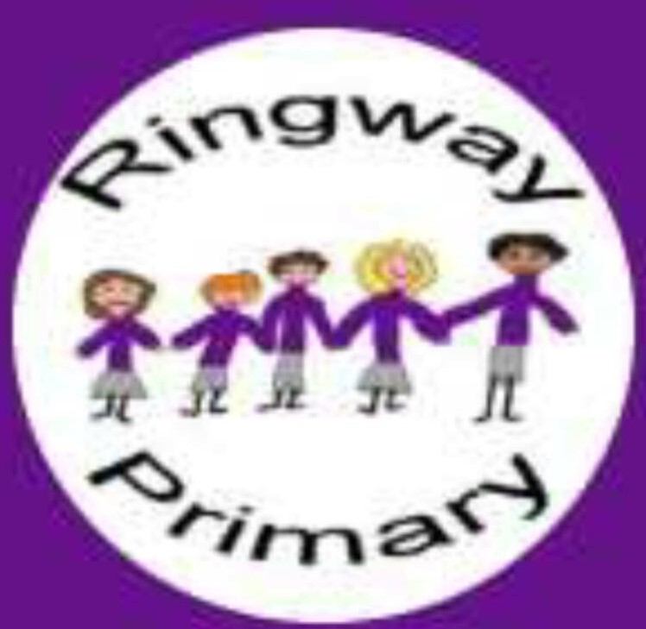
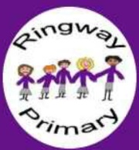

The more you know about the past, the better prepared you are for the future – Theodore Roosevelt

Intent | Implementation | Impact
What will take place before teaching in the classroom? | What will this look like in the classroom? | How will this be measured?
The school’s leadership team will:  - Lead the school staff to develop a clear overarching curriculum intent which drives the ongoing development and improvement of all curriculum subjects.  - Ensure that the curriculum leaders have appropriate time to develop their subject specific curriculum intent through careful research and development.  - Provide sufficient funding to ensure that implementation is high quality. | Our teaching sequence will be:  - Placing of the history being studied in the chronological context of previous learning, using the class timeline.  - Brief review of learning covered in previous lesson/s.  - Specific key vocabulary to be used and its definition.  - Conduct Historical enquiry using a variety of sources and/ or artefacts.  - Interpret their findings.  - Communicate their historical knowledge and understanding appropriately.  - Evaluate their learning and compare with other historical periods studied as appropriate. | Pupil Voice will show:  - A developed understanding of the methods and skills of historians at an age appropriate level  - A progression of understanding, with appropriate vocabulary which supports and extends understanding.  - Confidence in discussing history, their own work and identifying their own strengths and areas for development.
The curriculum leader will:  - Understand and articulate the expectations of the curriculum to support teaching and support staff in the delivery.  - Ensure an appropriate progression of knowledge is in place which supports pupils in knowing more and remembering more as historians.  - Ensure an appropriate progression of history skills and knowledge is in place over time so that pupils are supported to be the best historians they can be, and challenge teachers to support struggling historians and extend more competent ones.  - Ensure an appropriate progression for vocabulary is in place for each phase of learning, which builds on prior learning.  - Keep up to date with current history research and subject development through an appropriate subject body or professional group. | Our classrooms will:  - Provide appropriate quality equipment for each area of the curriculum.  - Have developed learning walls which include actual pieces of work, carefully chosen vocabulary, a topic specific timeline and a key stage timeline.  - Be organised so that pupils can work in small groups or whole class as appropriate to support pupils in development of their skills.  - Deploy appropriately challenging selections of texts, both non-fiction and fiction, accessible throughout learning to develop wider understanding and underpin reading skills. | Displays around school and books will show:  - Pupils have had opportunities for practice and refinement of skills.  - A varied and engaging curriculum which develops a range of historical skills.  - Developed and final pieces of work which showcase the skills learned.  - Clear progression of skills in line with expectations set out in the progression grids  - That pupils, over time, develop a range of skills and techniques across all of the areas of the historical curriculum.
The class teacher will, with support from the curriculum leader:  - Create a long term plan which ensures appropriate coverage of knowledge, skills and vocabulary from the progression grid.  - Personally pursue support for any particular subject knowledge and skills gaps prior to teaching.  - Ensure that resources are appropriate, of high quality and are plentiful so that pupils have the correct tools and materials. | Our children will be:  - Engaged because they are challenged by the curriculum which they are provided with.  - Resilient learners who overcome barriers and understand their own strengths and area for development.  - Able to critique their own work as a historian because they know how to be successful.  - Safe and happy in history lessons which give them opportunities to explore their own creative development.  - Encouraged and nurtured to overcome any barriers to their learning or self-confidence because feedback is positive and focuses on historical skills and knowledge  - Develop historical skills and confidence over time because of careful planning, focused delivery and time to practice and hone skills. | The curriculum leader will:  - Celebrate the successes of pupils through planned displays.  - Collate appropriate evidence over time which evidences that pupils know more and remember more.  - Monitor the standards in the subject to ensure outcomes are at expected levels.  - Provide ongoing CPD support based on the outcomes of subject monitoring to ensure the impact of the curriculum is wide reaching and positive.

